This is the Title of My Thesis
by
JOHN DOE SMITH

Presented to the Graduate Faculty of
The University of Texas Health Science Center at Tyler
In Partial Fulfillment of the Requirements

For the Degree of
Master of Science in Biotechnology

The University of Texas Health Science Center at Tyler
MONTH YEAR
SIGNATURE PAGE

This is the Title of My Thesis

by

John Doe Smith
APPROVED:
Professor 1, Thesis Director
Professor 2, Committee Chair
Professor 3, Committee Member
Professor 4, Committee Member
Professor 5, Committee Member
Pierre F. Neuenschwander, PhD
Office of Academic Affairs

ABSTRACT
This is the text of the abstract. It is limited to 150 words so that it can be published without taking up a lot of space. It should be short and sweet, but descriptive. Typically one or two sentences each for the introduction, methodology or strategy, results and conclusions.

PREFACE
(optional)

ACKNOWLEDGMENTS
(optional)

TABLE OF CONTENTS
ABSTRACT ii
PREFACE iii
ACKNOWLEDGMENTS iv
TABLE OF CONTENTS v
LIST OF FIGURES vi
LIST OF TABLES vii
LIST OF ABBREVIATIONS viii
INTRODUCTION 1
Section 1 Title 1
Section 2 Title 1
RESEARCH HYPOTHESIS 2
MATERIALS AND METHODS 3
Method 1 3
Method 2 3
RESULTS 4
Result 1 4
DISCUSSION 7
REFERENCES 8
APPENDIX 9
VITA 10

LIST OF FIGURES
Figure 1. This is the title of Figure 1 ……….……….......…………..…..…….. ..4
Figure 2. This is the title of Figure 2 …….………….........................................6
Figure 3. This is the title of Figure 3 ..........................................………….... ##
Figure 4. This is the title of Figure 4 .....................……………….......……… ##
Figure 5. This is the title of Figure 5 ...................................……................... ##
Figure 6. This is the title of Figure 6…………………................................…. ##
Figure 7. This is the title of Figure 7 ……….................………………....….... ##

LIST OF TABLES
Table 1. This is the title of Table 1 ……….……….......…………..…....…….. ##
Table 2. This is the title of Table 2 …….…………......................................... ##
Table 3. This is the title of Table 3 ..........................................………...….... ##

LIST OF ABBREVIATIONS
Provide a listing of abbreviations used. If an abbreviation is used less than three times in the thesis, do not use the abbreviation and spell out the full name. Delete these instructions and replace the example list below with your own list.

BSA: Bovine Serum Albumin
FVII: Blood Coagulation Factor VII
FVIIa: Activated Blood Coagulation Factor VII
TF: Tissue Factor
TNF-α: Tumor Necrosis Factor Alpha
etc.

INTRODUCTION

Section 1 Title
Provide background information about the field. This should cover all aspects of the field needed to understand the proposed research.

Section 2 Title
The introduction should have sufficient detail that an individual not in the field will be able to understand the current pertinent previous research in the area. State the question that will be addressed clearly and specifically.
Use a plethora of sources especially primary sources such a scientific journal articles. Document your summary with citations of the literature. Remember to cite thoroughly and properly. This need not be a complete bibliography, but should indicate that the state of knowledge in the proposed field has been surveyed.
The review should provide a general basis to use in evaluating the proposed research.

RESEARCH HYPOTHESIS
Make a clear, concise statement of the objectives of the proposed research and the questions that you hope to answer. Based on what is known in the field, explain what you expect to see and hope to show through your work.

MATERIALS AND METHODS
Describe your experimental methods in depth (not a protocol, but a description of the important parameters such as final reactant concentrations, pH, temperature, buffer composition etc.).

Method 1
Describe the techniques used to address the hypothesis. When a technique is common, references are allowable with any modifications of the general procedure identified and described. Non-standard or novel procedures must be described in greater detail.

Method 2
As much as possible, describe any specific important equipment and reagents that were used and that would be needed to reproduce the experiments, the controls that were used, and the number of replicates that were performed.

RESULTS
A
B
This is a description of the results. Each result typically has a clear one-sentence introduction with a reason for doing it. Followed by any specifics of the experimental set-up or changes from anything described in the Methods section.

Result 1
The result of each experiment should then be described and the related figure(s) or table(s) referred to and well-explained (Figure 1). Typically, the results do not contain discussion or necessarily any conclusion, although at times some conclusions are required to lead to the next experiment. Be judicious in “telling your story” in the clearest possible manner and leave speculation or detailed discussion for the DISCUSSION section.
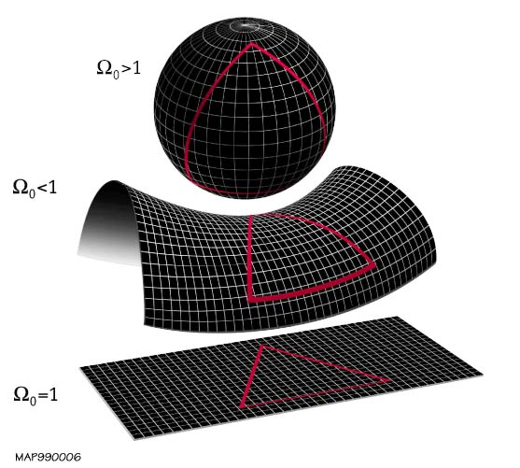
<Replace figure image above with your own image (jpeg, bmp, png, tif)>
Figure 1: This a brief title for the figure. The rest of this is the figure legend that briefly describes specifics about the experiment so the reader can glean why and how the experiment was done. If the figure has multiple panels, the description of each panel should be provided next to guide the reader. (A) This describes the results shown in Panel A. (B) This would describe the results in Panel B. Typically, the last line indicates the number of replicates and perhaps the statistics performed, if any. If these vary for each panel, this information should be provided at the end of the description for that panel. Remove the dotted line around this figure box. This is simply shown to indicate the margins. It can be resized and then copied elsewhere as needed.

Result 2
Large figures can be shown in landscape format if needed (Figure 2). These are generally on a separate page. Be very careful to maintain the proper margins throughout. If the figure has multiple panels, the description of each panel should be provided next to guide the reader. (A) This describes the results shown in Panel A. (B) This would describe the results in Panel B. Typically, the last line indicates the number of replicates and perhaps the statistics performed, if any. If these vary for each panel, this information should be provided at the end of the description for that panel.

A B
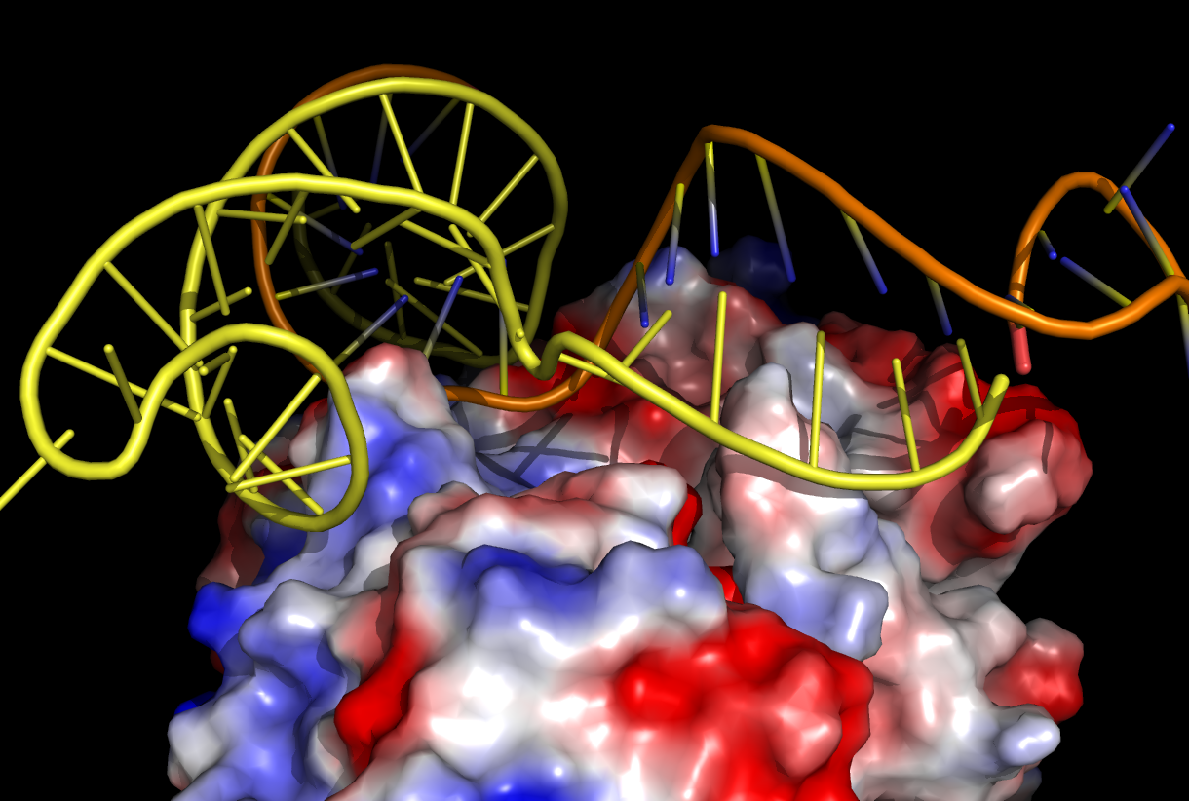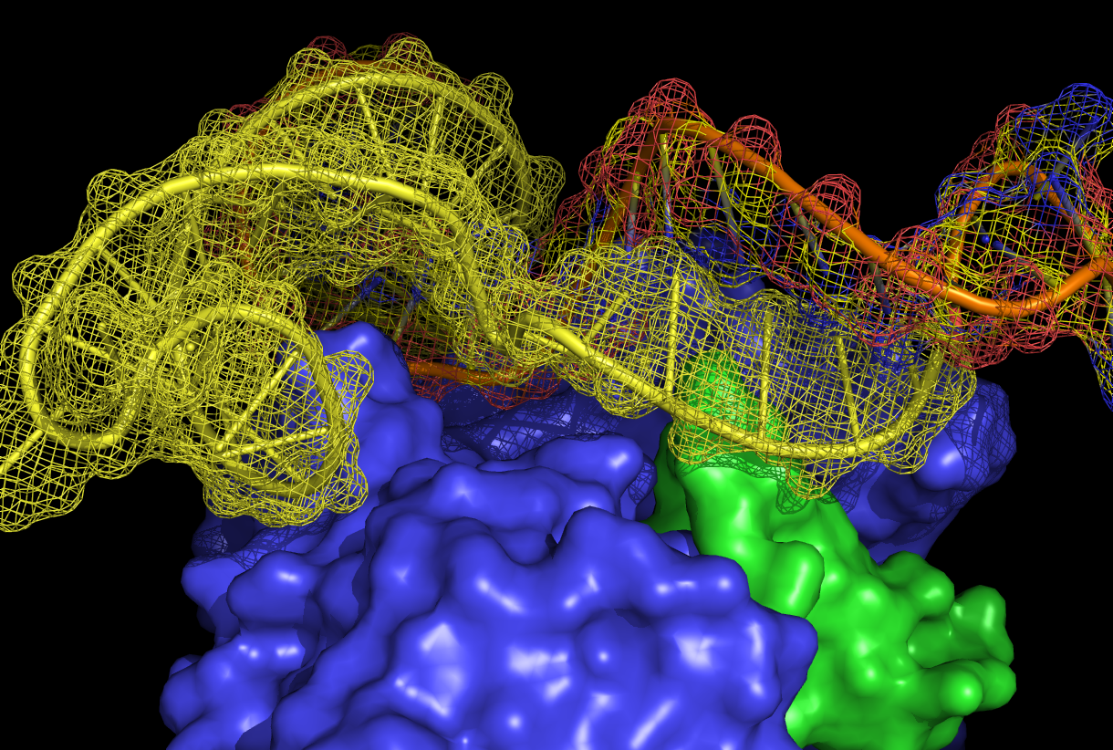

Figure 2: Large figures can be shown in landscape format if needed. These are generally on a separate page. Be very careful to maintain the proper margins throughout. If the figure has multiple panels, the description of each panel should be provided next to guide the reader. (A) This describes the results shown in Panel A. (B) This would describe the results in Panel B. Typically, the last line indicates the number of replicates and perhaps the statistics performed, if any. If these vary for each panel, this information should be provided at the end of the description for that panel.

DISCUSSION
This is where you elaborate on what the results mean, how you interpret them, how they fit into the “big picture” in the field and maybe the “bigger picture” in science. Figures such as cartoons are allowed and sometimes helpful in proposing new models or theories based on these results.

The discussion section should have a final paragraph that summarizes everything as well as proposes future studies or directions.

REFERENCES
- Datta, A., & Scotton, C.J. (2011) Novel therapeutic approaches for pulmonary fibrosis. British J. Pharmacol., 163:141-72.
- King, T., Pardo, A., & Selman, M. (2011) Idiopathic Pulmonary Fibrosis. Lancet, 378:1949-61.
- Adamali, H.I., & Maher, T.M. (2012) Current and novel drug therapies for idiopathic pulmonary fibrosis. Drug Des. Devel. Ther., 6:261-272.
- Loomis-King, H., Flaherty, K.R., & Moore, B.B. (2013) Pathogenesis, current treatments and future directions for idiopathic pulmonary fibrosis. Curr. Opin. Pharmacol., 13:377-85.
- Maher, T.M. (2010) Pirfenidone in idiopathic pulmonary fibrosis. Drugs Today (Barc.) 46:473-82.
- Moore, B.B., Lawson, W.E., Oury, T.D., Sisson, T.H., Raghavendran, K., & Hogaboam, C.M. (2013) Animal models of fibrotic lung disease. Am. J. Respir. Cell. Mol. Biol., 49:167-79.

APPENDIX
(optional)

VITA
After graduating from Dallas South High School in Dallas, TX in 2005, John Smith entered the University of Texas at Tyler in Tyler, TX as an undergraduate student majoring in Chemistry. He graduated Summa Cum Laude with a Bachelor of Science in Chemistry in May 2009. In August of that year he entered into the Biotechnology graduate program at the University of Texas Health Science Center at Tyler where he performed his thesis work in the lab of Howard S. Fine, PhD. John received his Master of Science in Biotechnology degree in June 2011 and has been accepted into Medical School at the University of Texas MD Anderson Cancer Center, Houston, TX to begin July 2011.

This thesis was typed by John Doe Smith

